Staff Maintenance Menu

Screen Shot:

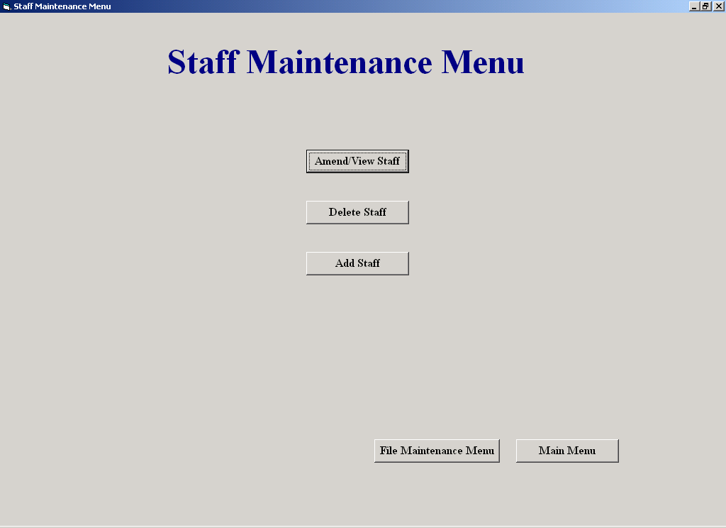

Purpose of the Screen:

Allows the user access to staff processing screens such as, Delete a Staff Member and
Amend/View Staff.

How to get to the Screen:

Click File Maintenance on the Main Menu, and then click Staff File Processing.

How to use the Screen:

- The user chooses an option and clicks on it

Clock In Staff

Screen Shot:

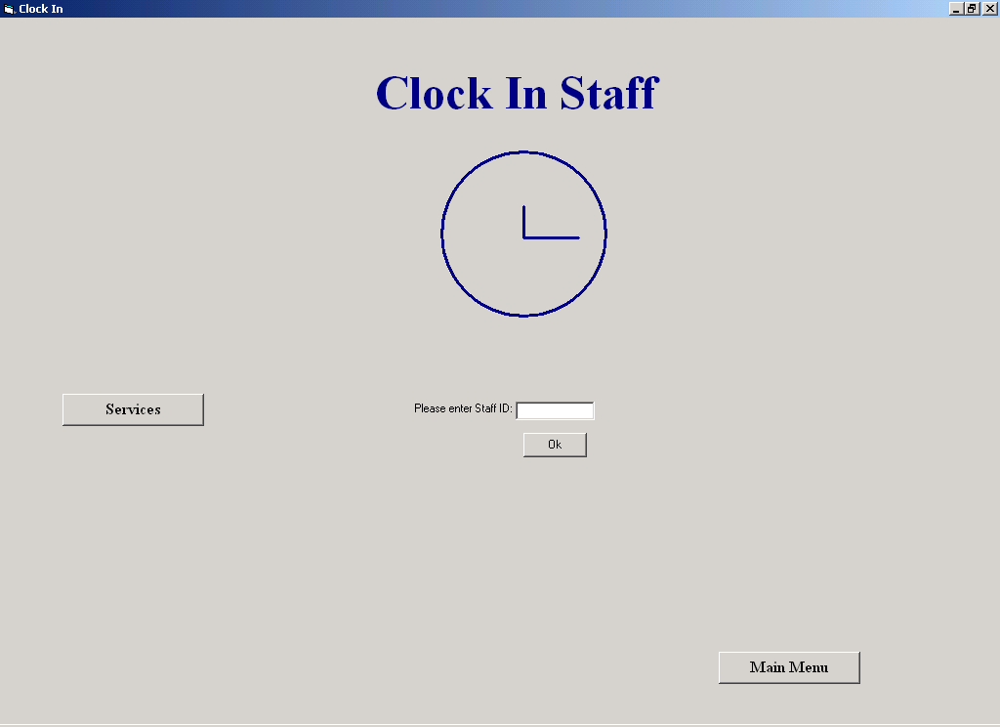

Purpose of the Screen:

This screen allows the user to clock in or out

How to get to the Screen:

Choose the Staff Clock-In option on the Main Menu

How to use the Screen:

- Enter your employee ID and click "OK".
If the ID that was entered is not a valid ID, the following message will appear on the screen:

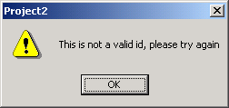

Services

Screen Shot:

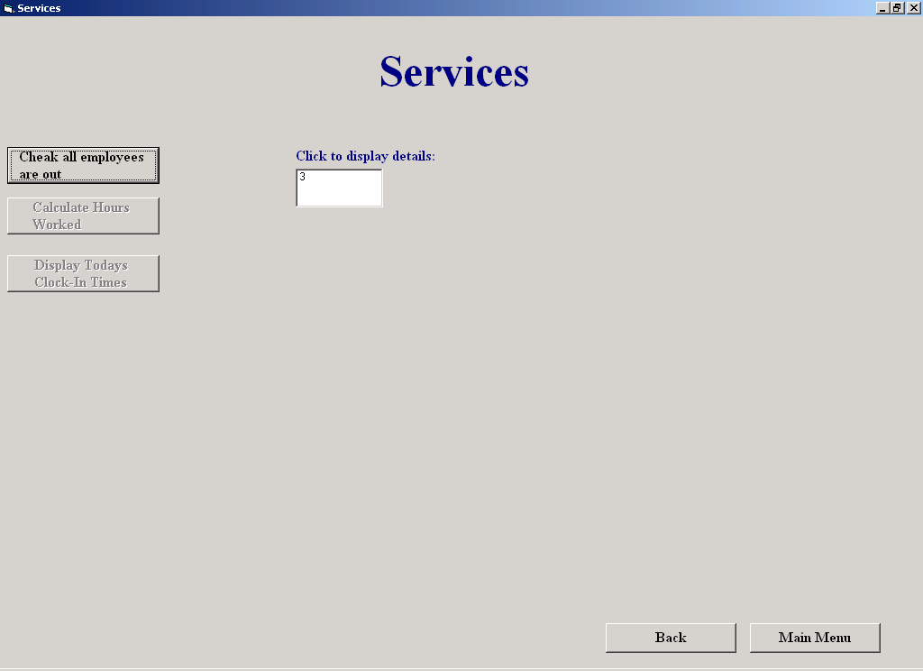

Purpose of the Screen:

This screen allows the user to check that all employees are clocked out. Once all employees are clocked out, the user can then calculate the hours worked for the week of each employee. The user can also get a listing of clock in times for the day, the system automatically marks those employees who arrived late and those who left early.

How to get to the Screen:

Choose the Staff Clock-In option on the Main Menu and then click the Services button on the Staff Clock-In screen

How to use the Screen:

- Click “Check all employees are out”.
If every employee has clocked out, the following message will appear:
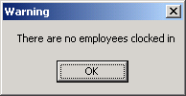

A listing of those who haven't clocked out, is displayed.
- Click on the ID number to view their details
- Click “Supply Clock-Out Time”
- Click the Hours combobox to choose the hours
- Click the Minutes combobox to choose the minutes
- Click "OK":

Once all employees are clocked out, the user can calculate the hours worked for the week:
- Click "Calculate Hours Worked"
A list of clock in times for the day can be also be displayed:
- Click "Display Today’s Clock-In Times":
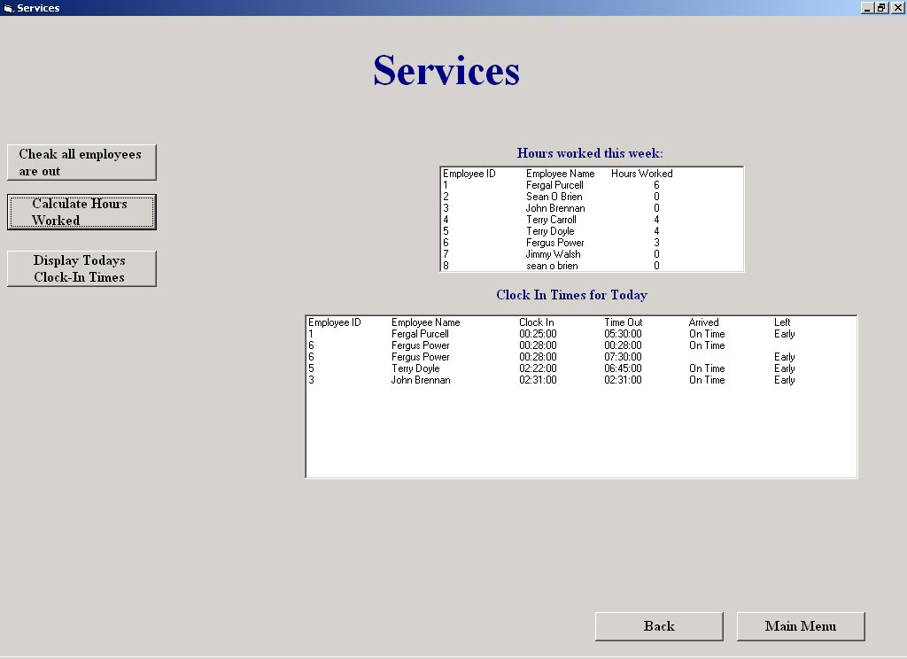
Add Supplier

Screen Shot:

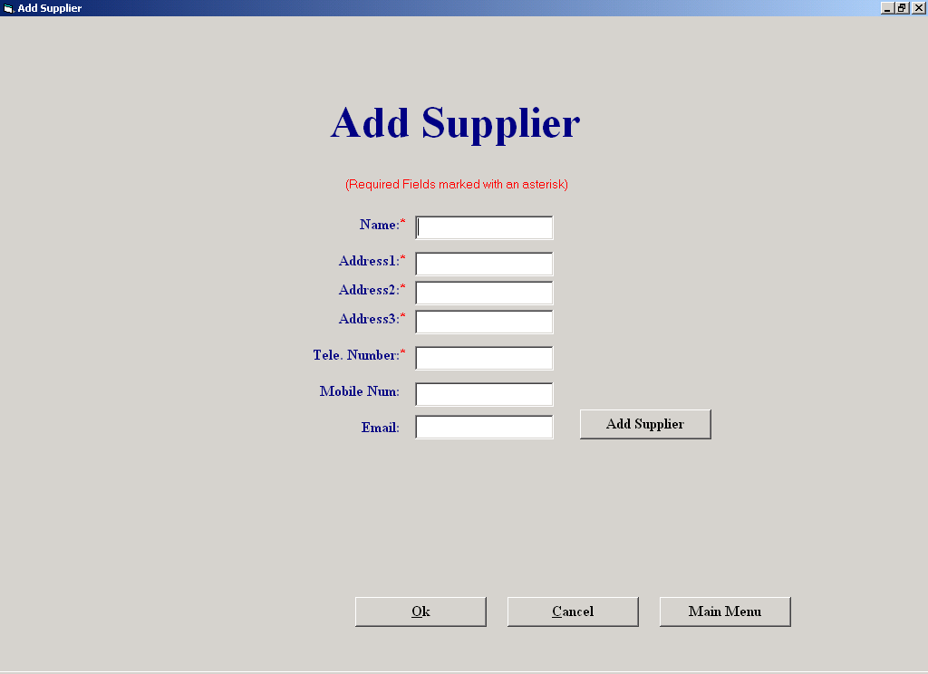

Purpose of the Screen:

The purpose of this screen is to allow the user to enter the details of a new supplier.

How to get to the Screen:

Click File Maintenance on the Main Menu, and then click Supplier File Processing. Then choose the Add Supplier option on the Supplier Maintenance Menu

How to use the Screen:

- Enter the details of the supplier in the relevant textboxes
- Click "Add Supplier".
If the supplier already exists in the system, the following message appears:
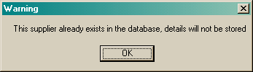
If the you want to cancel any suppliers that were entered since this screen was last invoked, Click "Cancel"

Amend/View Supplier

Screen Shot:

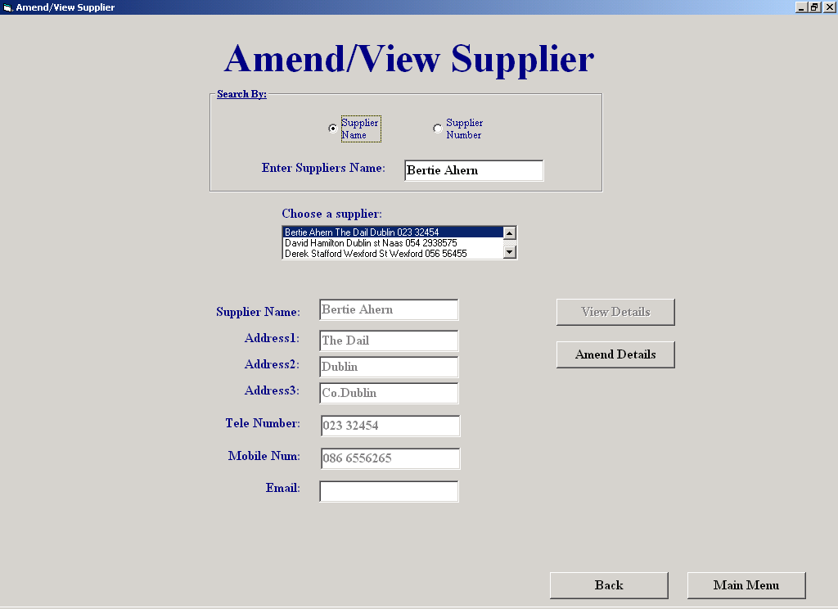

Purpose of the Screen:

This screen will allows the user amend or simply view an existing supplier's details

How to get to the Screen:

Click File Maintenance on the Main Menu, and then click Supplier File Processing. Then choose the Amend/View Supplier option on the Supplier Maintenance Menu

How to use the Screen:

- Enter the supplier's id or name or select a supplier from the list.
If the supplier doesn’t exist, the following message will appear:
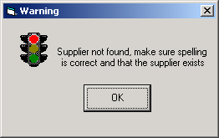
When found, the rest of the supplier's details are displayed in view mode.
If you wish to change the supplier’s details:
- Click the "Amend" button and amend the details.
- To cancel the amendments, click "Cancel"
- To save the changes:
- Click "Save Changes", the following message appears:
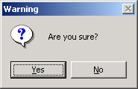
- Click “Yes” to save the changes.

Delete a Staff Member

Screen Shot:

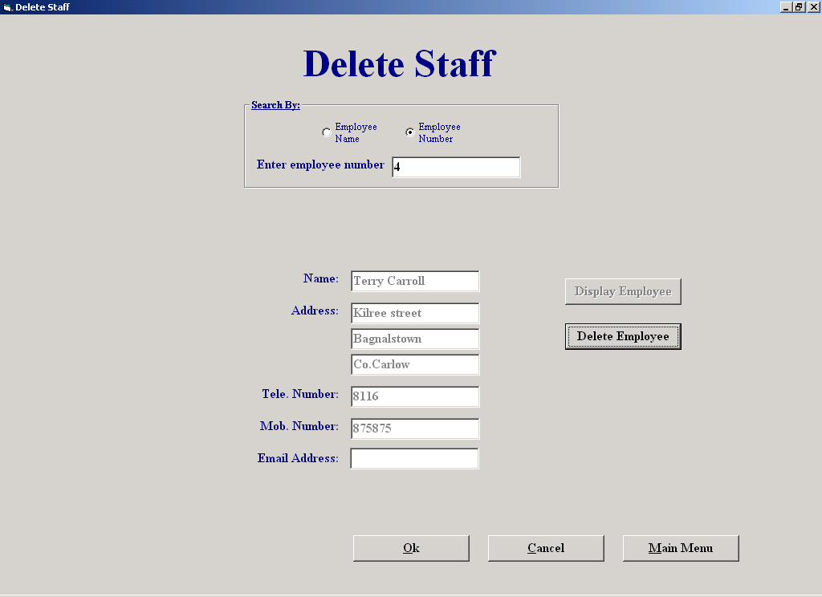

Purpose of the Screen:

This screen allows the user to delete an existing staff member's details from the database

How to get to the Screen:

Click File Maintenance on the Main Menu, and then click Staff File Processing. Then choose the Delete Staff option on the Staff Maintenance Menu

How to use the Screen:

- Enter the staff member's ID or name.
If the employee is not found, the following message appears:
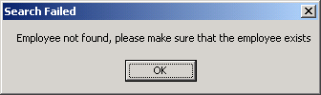
When found, the rest of the staff member's details are displayed.
- To delete the record from the database:
- Click the "Delete Employee" button, the following message appears:

To delete the employee, click “Yes”.

Customer Report

Screen Shot:

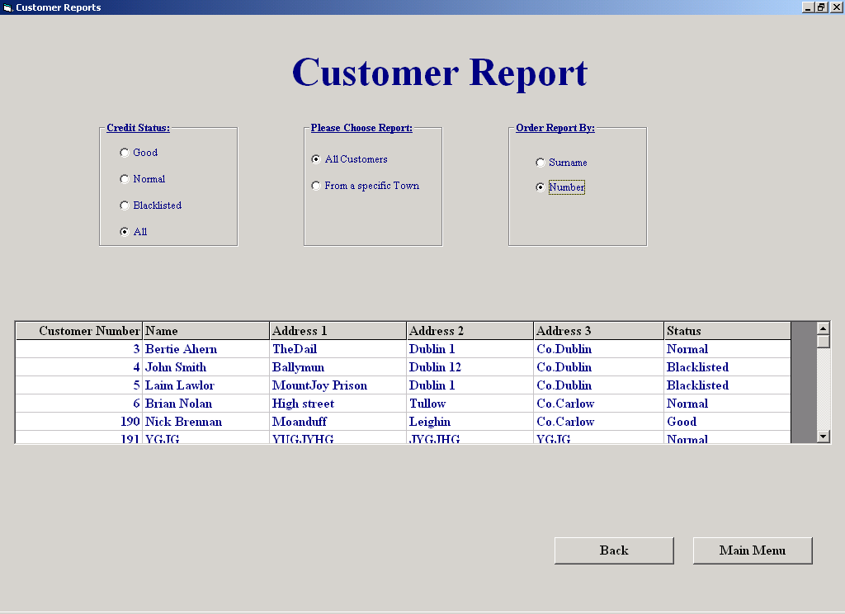

Purpose of the Screen:

This screen allows the user to produce reports on customer details.

How to get to the Screen:

Choose the Reports option on the Main Menu and then click on the Customer Details Report button on the Reports Menu

How to use the Screen:

- Choose a Credit Status
- Choose either a list of all customers matching it by clicking "All customers", or a list of all customers from a particular town matching it by clicking "From a Specific town".
- Sort the report by either Customer Surname, by clicking "SurName" or by Customer Number by clicking "Number".

